# Appendix F: Full Incremental Analyses

## Introduction

This appendix presents full incremental analyses, including efficiency frontiers, for the following four patient groups:

* Males, aged 50 years at diagnosis
* Females, aged 50 years at diagnosis
* Males, aged 65 years at diagnosis
* Females, aged 65 years at diagnosis

## Males, aged 50 years at diagnosis

The cost-effectiveness plane for this patient group is shown in Figure 1. Of the four strategies evaluated, the No TTE strategy, using Rivaroxaban as the OAC of choice, is estimated to dominate all the other three options.

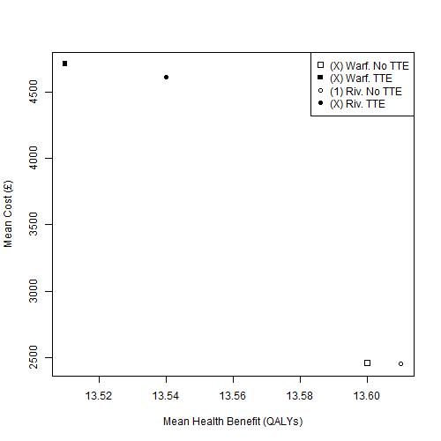

Figure Cost-effectiveness plane of mean costs and mean QALYs for males aged 50 years at diagnosis. Warf: Warfarin; Riv: Rivaroxaban; TTE: Transthoracic Echocardiography

## Females, aged 50 years at diagnosis

The cost-effectiveness plane for this patient group is shown in Figure 2. As for males of the same age, of the four strategies evaluated, the No TTE strategy, using Rivaroxaban as the OAC of choice, is estimated to dominate all the other three options. However, the differences in estimated cost and QALY benefit between this option and the No TTE strategy using Warfarin as the OAC of choice are extremely small.

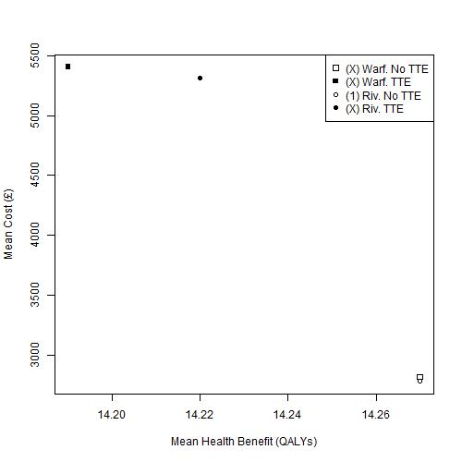

Figure 2 Cost-effectiveness plane of mean costs and mean QALYs for females aged 50 years at diagnosis. Warf: Warfarin; Riv: Rivaroxaban; TTE: Transthoracic Echocardiography

## Males, aged 65 years at diagnosis

The cost-effectiveness plane for this patient group is shown in Figure 3. Of the six strategies evaluated, the No TTE strategy using dabigatran as the OAC of choice (Dab, No TTE) is estimated to be the lowest cost option, and so forms the start of the efficiency frontier. The equivalent TTE strategy (Dab, TTE) forms the next and final part of the efficiency frontier, with an ICER, compared with Dab, No TTE, of £14 728 / QALY, as shown in Appendix E. All other options are ruled out by simple or extended dominance.

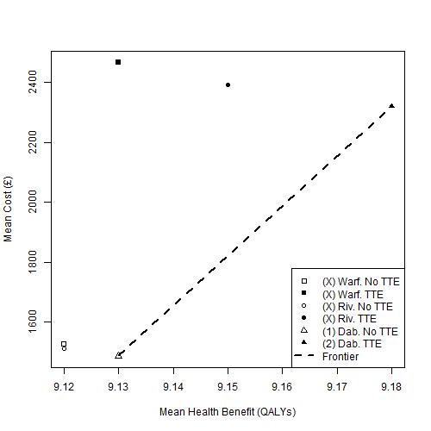

Figure 3 Cost-effectiveness plane of mean costs and mean QALYs for males aged 65 years at diagnosis. Warf: Warfarin; Riv: Rivaroxaban; Dab: Dabigatran; TTE: Transthoracic Echocardiography

## Females, aged 65 years at diagnosis

The cost-effectiveness plane for this patient group is shown in Figure 4. As for males of the same age, of the six strategies evaluated, the strategy Dab, No TTE is estimated to be the cheapest, and so forms the start of the efficiency frontier. The next and final option in the frontier is the strategy Dab, TTE, with an ICER of £12 314 / QALY, as shown in Appendix E. All other options are estimated to be ruled out by simple or extended dominance. However, the absolute differences in costs and QALYs between the Riv. No TTE and Dab. No TTE options are extremely small.

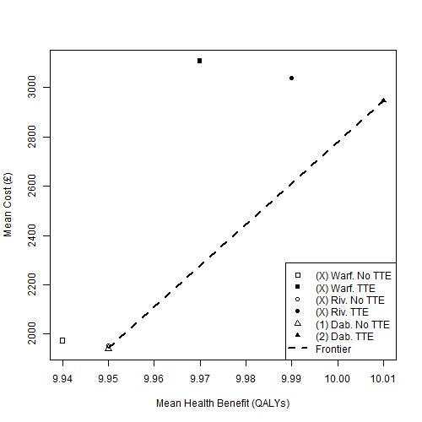

Figure 4 Cost-effectiveness plane of mean costs and mean QALYs for females aged 65 years at diagnosis. Warf: Warfarin; Riv: Rivaroxaban; Dab: Dabigatran; TTE: Transthoracic Echocardiography

# Appendix G: Additional Exploratory Analysis – the relationship between true prevalence of LAABN and mean ICER

## Introduction

This appendix illustrates how the mean ICER estimates change, for each of the four patient groups, as a function of the estimated proportion of the patients with LA ABN, here defined as true proportion high risk (TPHR).

## Males, aged 50 years at diagnosis

